Homework #0 (V1.0[1])

COP 3813 Fall 2017

© 2017 Saeed Rajput, Ph.D.

To prove that you have completed a certain activity, do not forget to take a snapshot of your screen that clearly includes a view of your FAU username or e-mail address.

You can save this Homework file as MS-Word file (File->Download As->Microsoft Word (.diocx) ) and provide answers within that document. All images, must be enclosed within a single WORD file. Homeworks submitted in multiple files will not be graded. Do not remove any original content from the file when editing the file to provide your responses.

# Problem 1: Handling Google Drive and Google Docs

1. Enable your FAU Google Drive so you can see the shared folder of this course. All material will be linked through the [AlwaysStartHere_cop3813](https://docs.google.com/document/d/1wpCd9yGrecEMEy4kJSnlLHbg6AyU4lEVX47INV-bgB0/edit#heading=h.fjvclgl7po2u) page, so go ahead and “Star” that page in google drive and also bookmark it in your “Firefox” or “Chrome” browser. Please avoid using MS-Edge or MS-IE browsers.
   * Many of you may have an existing personal gmail account on your phones, laptops and other devices. In this course you can only use your official yourusername@fau.edu account (which runs on google’s cloud SAAS[2] platform called Google Apps). It is possible to use both accounts on your android and your computer. Learn how to do that. Ask questions here from your fellow classmates if you cannot figure it out on your own.
   * I will have to refuse sharing the course content folder with you send me a sharing request from any other account other than yourusername@fau.edu.

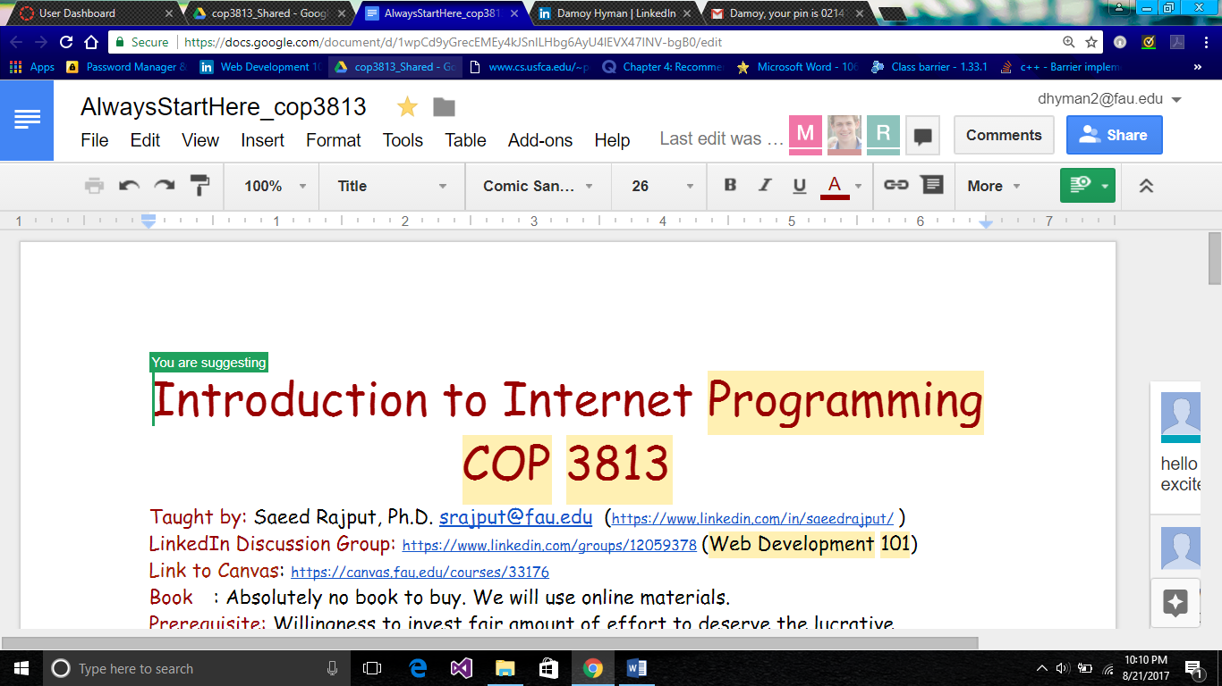

* The above screenshot shows the AlwaysStartHere_cop3813 page being starred and booked marked as well.

1. Enable Notifications on “comments” on [AlwaysStartHere_cop3813](https://docs.google.com/document/d/1wpCd9yGrecEMEy4kJSnlLHbg6AyU4lEVX47INV-bgB0/edit#heading=h.fjvclgl7po2u) page: Go to “Comments->Notifications->Enable All” so you get notified when somebody has a question. Remember, these are visible to all members of the class. Feel free to ask questions by posting comments. The comments can be entered by highlighting a specific area of text about which you have a question. If cluttered comments bother you, you can organize them using “Show Chat” feature next to the comments. You can also ask questions from within the Homework document like this one. Like so!
2. Place an introductory comment on the [AlwaysStartHere_cop3813](https://docs.google.com/document/d/1wpCd9yGrecEMEy4kJSnlLHbg6AyU4lEVX47INV-bgB0/edit#heading=h.fjvclgl7po2u) page

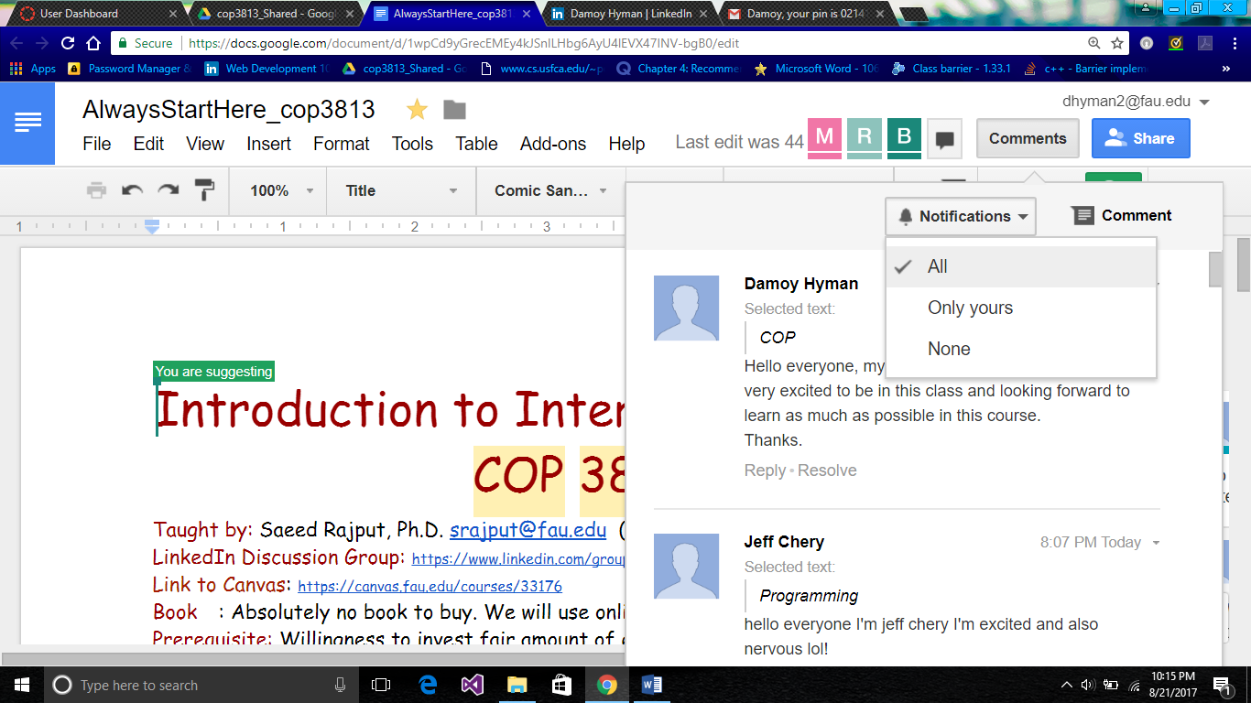

* The above screenshot shows the AlwaysStartHere_cop3813 comment notifications being set to “ALL” along with the introductory comment as well.

# Problem 2: Setting up LinkedIn & LinkedInGroup

1. If you are not already on LinkedIn, sign up for LinkedIn. LinkedIn is vital for you to get a job in the field of computing. Make sure that you use your correct name.
2. Send request to join the Web Development 101 <https://www.linkedin.com/groups/12059378>

By this time we have learnt to about two places to hold discussions and exchange ideas:

* 1. LinkedIn group and
  2. By placing comments inside google documents.

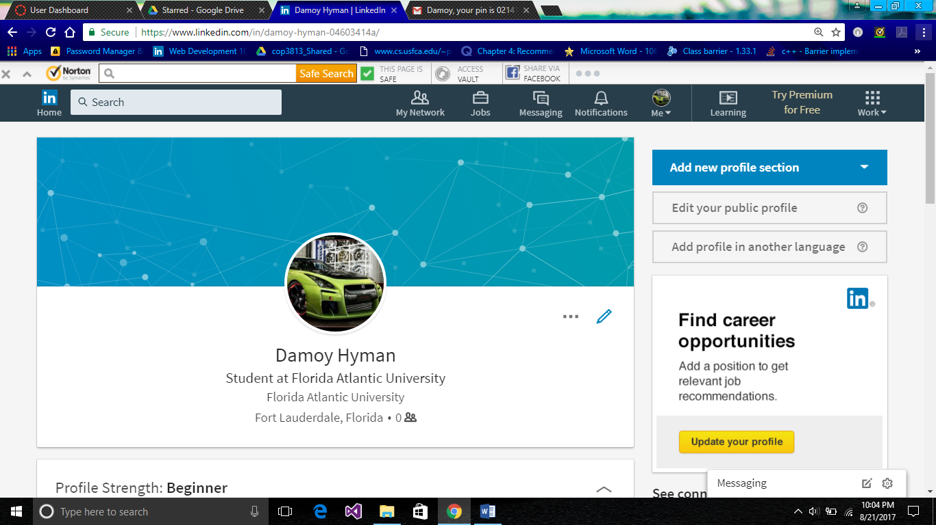

* The above screenshot shows the account that was created by and for the student (Damoy Hyman)

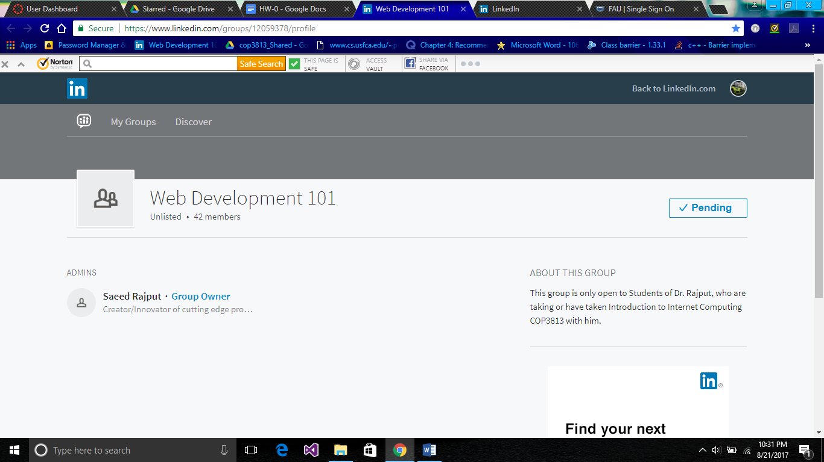

* The above screenshot shows the request to join Web Development 101 has been sent.

# Problem 3: Searching for a Job that you like and How to send Emails to the Instructor?

Throughout the duration of this course, whenever you want to send an e-mail to discuss a private matter with the instructor, you will have format the “subject” of the e-mail as specified below. You will practice sending an email to the instructor in this problem.

If you do not follow these guidelines, your e-mail may be ignored or worse go to the spam folder.

Do not use e-mails for content related discussions. Such discussions must be conducted as comments on google docs ( inside assignment/project/homework documents, on the [AlwaysStartHere_cop3813](https://docs.google.com/document/d/1wpCd9yGrecEMEy4kJSnlLHbg6AyU4lEVX47INV-bgB0/edit#heading=h.fjvclgl7po2u) page) or in the LinkedIn “Web Development 101” group.

Email address to use: [srajput@fau.edu](mailto:srajput@fau.edu)

You MUST use the subject line as follows:

COP3813:<YourLastName>,<YourFirstName>: title of e-mail.

You will not get a response if: you did not use the correct subject line.

Please also provide your full name and your Z number in the body of the e-mail.

## Example:

**Subject:COP3813:Rajput,Saeed:Question about Project 3**

**Professor,**

**I do not see my scores for project 3. Could you please look into it?**

**Thanks,**

**Saeed Rajput**

**Z00999999**

Pick your favorite Job search site (e.g. indeed.com ) and search for a “Web Developer” job that you like.

Send an e-mail to the instructor using the prescribed format, title = “HW 0”, and the link of the job you found in the body of the e-mail.

## FAQs about this Homework:

(HW-0 related questions that do not belong to any specific problem above can be posted below as comments below. Highlight an available number and place your question as comment See example 1 below).

Question 1

Question 2

Question 3

Question 4

Question 5

Question 6

Question 7

Question 8

Question 9

Question 10

1. What does Verion 1.0 mean? It mean that the assignment is now ready. You can start working on it. There might be some minor enhancements made in the assignments in the future based on the feedback received from some students. When that happens, the version will be changed and you will be notified.
2. More on this later. This Web 101 course, but to become a Jedi, you have to be in the “Cloud”. You will get there, but will need more training in the ways of the force.